**MTBF Calculation for Gas Sensing System**

**Introduction**

## Calculation of MTBF for Gas Sensing System Using Raspberry Pi Pico, MQ2 Gas Sensor, and Traffic Lights

### Introduction

Mean Time Between Failures (MTBF) is a critical parameter for assessing the reliability of a system. In this part of our report, we calculate the MTBF for a gas sensing system comprising a Raspberry Pi Pico, an MQ2 gas sensor, and traffic lights. MTBF represents the expected operational time between inherent failures of a system. We will consider the MTBF of the Raspberry Pi Pico in a ground benign environment, assume the operational life of the MQ2 gas sensor, and provide an example calculation for the traffic light system. However, the final MTBF calculation will exclude the traffic light system to avoid skewing the results due to the lack of specific data.

**Ground Benign Environment**

A ground benign environment refers to a controlled and stable environment where conditions are mild and predictable. Characteristics include:

1. Stable and moderate temperatures.
2. Low humidity levels.
3. Minimal mechanical stress, vibration, and shock.
4. Clean and dust-free atmosphere.
5. Reliable and stable power supply.

Such conditions contribute to longer lifespans and higher MTBF values for electronic components.

**MIL-HDBK-217F Standard**

MIL-HDBK-217F is a widely recognized reliability prediction standard used across various industries. It provides methods for estimating the reliability of electronic components and systems based on empirical data and failure rate models. The standard categorizes components based on their environmental conditions and provides specific prediction models for different types of components.

**MTBF Calculation Methodology**

We will follow the MIL-HDBK-217F standard to calculate the MTBF of the gas sensing system. The calculation involves estimating the failure rates (λ) for each component type and then combining them to determine the overall system MTBF.

### MTBF Calculation Methodology

To calculate the MTBF for the system, we use the following steps:

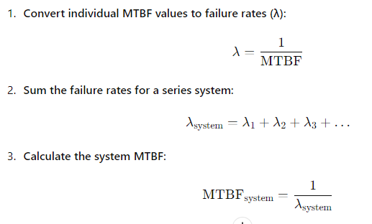

**Components and MTBF Data**

1. **Raspberry Pi Pico**
   * The Raspberry Pi Pico is a microcontroller board based on the RP2040 microcontroller chip. According to the official Raspberry Pi website, the Raspberry Pi Pico has an MTBF of 183,000 hours in a ground benign environment. The differences between the Pico and Pico W, primarily the addition of wireless capabilities in the Pico W, do not significantly affect the MTBF for our use case.

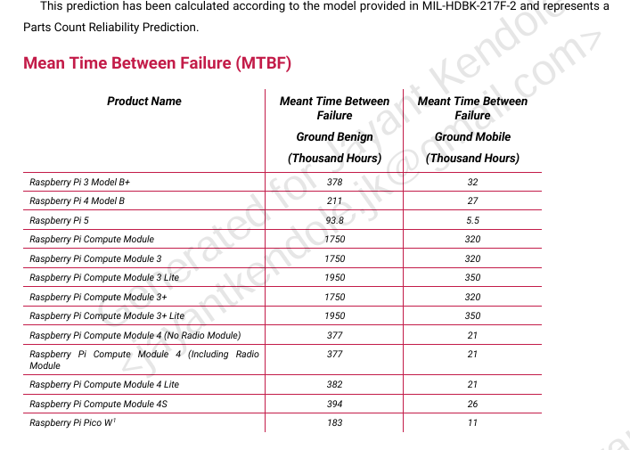

1. **MQ2 Gas Sensor**
   * The MQ2 gas sensor is an electrochemical sensor used for detecting gases like LPG, methane, and hydrogen. Official MTBF data for the MQ2 sensor is not available. Considering its regular operational life, we assume a conservative operational life of 2 years (17,520 hours).

**Components and MTBF Values**

1. **Raspberry Pi Pico:**

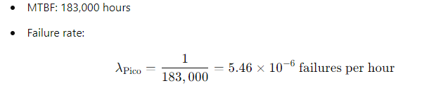

1. **MQ2 Gas Sensor:**

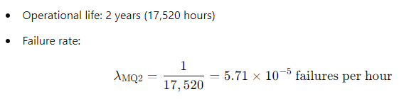**System Failure Rate and MTBF Calculation**

1. **Combined Failure Rate:**

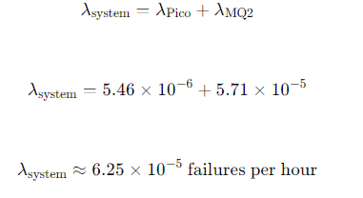

1. **System MTBF:**

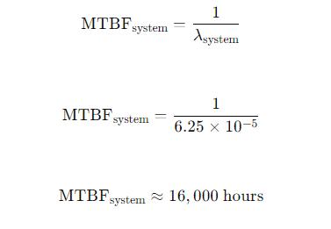

**Example MTBF calculation of LED traffic lights.**

**Components and MTBF Values**

1. **LEDs (Light Emitting Diodes)**
   * LEDs are semiconductor devices that emit light when current flows through them. MTBF values for LEDs can vary significantly depending on the manufacturer and quality. A typical MTBF for high-quality LEDs can range from 50,000 to 100,000 hours.
2. **Diodes**
   * Diodes are semiconductor devices that allow current to flow in one direction only. MTBF values for diodes are typically high, often exceeding 100,000 hours for standard applications.
3. **Capacitors**
   * Capacitors store electrical energy temporarily and are rated based on their ability to maintain capacitance over time. MTBF values for capacitors can range widely, depending on their type and quality. For electrolytic capacitors commonly used in power supplies, MTBF values might range from 100,000 to 500,000 hours.
4. **Resistors**
   * Resistors are passive components used to limit current flow in circuits. They generally have very high MTBF values due to their simple construction and stable performance characteristics. MTBF values for resistors can exceed 1,000,000 hours in typical applications

**Example Calculation (Sample MTBF Values)**

Let’s assume typical MTBF values for each component type:

LED MTBF: 80,000 hours

Diode MTBF: 120,000 hours

Capacitor MTBF: 300,000 hours

Resistor MTBF: 1,000,000 hours

**Step-by-Step Calculation**

**Calculate Failure Rates:**

. 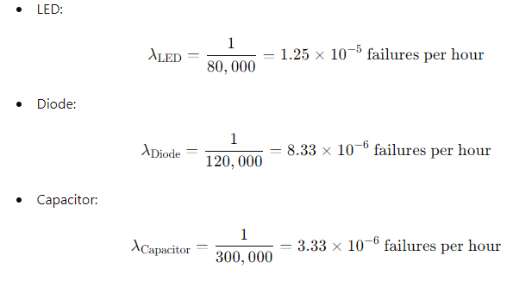

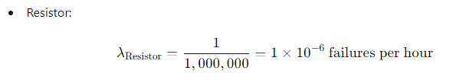

**Calculate Combined Failure Rate:**

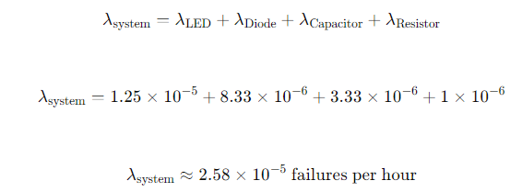

**Calculate System MTBF:**

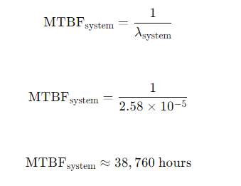

**Conclusion**

The MTBF calculation for the gas sensing system using the MIL-HDBK-217F standard estimates an MTBF of approximately 16,000 hours(1.8 years approximately). This calculation considers the MTBF of the Raspberry Pi Pico and the assumed operational life of the MQ2 gas sensor. MIL-HDBK-217F provides a systematic approach to reliability assessment, ensuring confidence in system performance predictions by accounting for various component types and operating conditions.

<https://pip.raspberrypi.com/categories/606-reliability>

<https://reliabilityanalyticstoolkit.appspot.com/static/Mil-Hdbk-217_Environmental_descriptions.htm>

<https://www.winsen-sensor.com/d/files/PDF/Semiconductor%20Gas%20Sensor/MQ-2%20(Ver1.4)%20-%20Manual.pdf>

<https://www.crowcon.com/blog/how-long-will-my-gas-sensor-last/>

<https://forums.raspberrypi.com/viewtopic.php?t=260388>